Project #3 Image Registration and Color Images
Due Thursday October 13th.

RGB Photograph registration and colorizing

I really liked this project from the CMU 15-463 Computational Photography class at Carnegie Mellon. Most of the project description was written by Prof. Alexei Efros and has been adapted for our use from her project writeup.

Background

Sergei Mikhailovich Prokudin-Gorskii (1863-1944) [Сергей Михайлович Прокудин-Горский, to his Russian friends] was a man well ahead of his time. Convinced, as early as 1907, that color photography was the wave of the future, he won the Tzar's special permission to travel across the vast Russian Empire and take color photographs of everything he saw. And he really photographed everything: people, buildings, landscapes, railroads, bridges... thousands of color pictures! His idea was simple: record three exposures of every scene onto a glass plate using a red, a green, and a blue filter. Never mind that there was no way to print color photographs until much later -- he envisioned special projectors to be installed in "multimedia" classrooms all across Russia where the children would be able to learn about their vast country. Alas, his plans never materialized: he left Russia in 1918, right after the revolution, never to return again. Luckily, his RGB glass plate negatives, capturing the last years of the Russian Empire, survived and were purchased in 1948 by the Library of Congress. The Library of Congress has recently digitized the negatives and made them available on-line. (http://www.loc.gov/exhibits/empire/gorskii.html)

You will want the color separation negatives:
http://www.loc.gov/pictures/related/?q=Color%20separation%20negatives.&fi=formats&co=prok

There are almost 2000 of these but all you need to do is one or two for your final report. Some of the ones which may be interesting are:
#8
#14
#23
#39
#165
#1169 is the image shown below
#1173
#1806
#1824
#1868
#1869
#1870
#1898

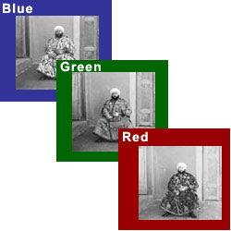
Figure 1. Sample R-G-B image

Overview
The goal of this assignment is to take the digitized Prokudin-Gorskii glass plate images and, using image processing techniques, automatically produce a color image with as few visual artifacts as possible. In order to do this, you will need to extract the three color channel images, place them on top of each other, and align them so that they form a single RGB color image. Some starter code is available in Appendix I; do not feel compelled to use it. We will assume that a simple x,y translation model is sufficient for proper alignment. However, extra points will be given if your alignment also includes rotational. The full-size glass plate images are very large, so your alignment procedure will need to be relatively fast and efficient.

Details
Some of the digitized glass plate images (both hi-res and low-res versions) are available from the CMU directory directory (note that the filter order from top to bottom is BGR, not RGB!):
http://graphics.cs.cmu.edu/courses/15-463/2011_fall/hw/proj1/data/
However, all the images are available from the Library of Congress website.

Your program will take a glass plate image as input and produce a single color image as output.

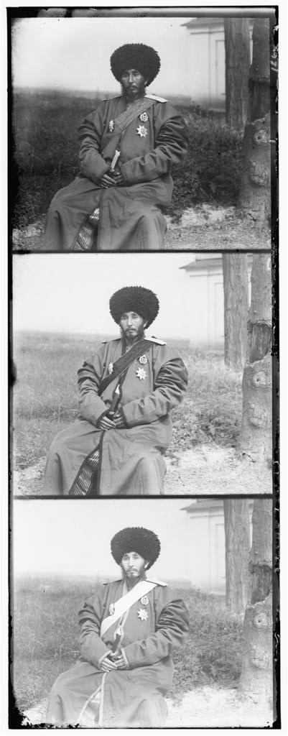
Figure 2. Typical Library of Congress Image. The images you download will contain all three negatives with blue at the top, green in the middle, and red on the bottom.

The program should divide the image into three equal parts and align the second and the third parts (G and R) to the first (B). For each image, you will need to print the (x,y) displacement vector that was used to align the parts.

The easiest way to align the parts is to exhaustively search over a window of possible displacements (say [-15,15] pixels), score each one using some image matching metric, and take the displacement with the best score. There is a number of possible metrics that one could use to score how well the images match. The simplest one is just the L2 norm also known as the Sum of Squared Differences (SSD) distance which is simply sum(sum((image1-image2).^2)). Another is normalized cross-correlation (NCC), which is simply a dot product between two normalized vectors: (image1./||image1|| and image2./||image2||). Note that in this particular case, the images to be matched do not actually have the same brightness values (they are different color channels), so a cleverer metric might work better.

Exhaustive search will become prohibitively expensive if the pixel displacement is too large (which will be the case for high-resolution glass plate scans). In this case, you will need to implement a faster search procedure such as an image pyramid. An image pyramid represents the image at multiple scales (usually scaled by a factor of 2) and the processing is done sequentially starting from the coarsest scale (smallest image) and going down the pyramid, updating your estimate as you go. It is very easy to implement by adding recursive calls to your original single-scale implementation.

Your job will be to implement an algorithm that, given a 3-channel image, produces a color image as output. Implement a simple single-scale version first, using for loops, searching over a user-specified window of displacements. The above directory has skeleton Matlab code that will help you get started. Next, add a coarse-to-fine pyramid speedup to handle large images.

Some references on coarse-to-fine registration which have been placed on Blackboard:
- Chapter 6 of GWE, Geometric Transforms and Image Registration
- Greg Ward, “Fast, Robust Image Registration for Compositing High Dynamic Range Photographs from Handheld Exposures,” J.Graphics, GPU and Game Tools, Vol. 8, No. 2, 2002.
- Ahmet Akyuz, “Photographically Guided Alignment for HDR Images,” Eurographics 2011.
- Johan Mathe and Tim Wong, “High Dynamic Range Imaging with the Android Platform,” Project report for EE 368 at Stanford. Look at Section C for a simple explanation of their image registration.

Bells & Whistles (Extra Credit)
Although the color images resulting from this automatic procedure will often look strikingly real, they are still a far cry from the manually restored versions available on the Library of Congress website and from other professional photographers. Of course, each such photograph takes days of painstaking Photoshop work, adjusting the color levels, removing the blemishes, adding contrast, etc. Can we make some of these adjustments automatically, without the human in the loop? Feel free to come up with your own approaches or talk to me about your ideas. There is no right answer here -- just try out things and see what works. For example, the borders of the photograph will have strange colors since the three channels won't exactly align. See if you can devise an automatic way of cropping the border to get rid of the bad stuff. One possible idea is that the information in the good parts of the image generally agrees across the color channels, whereas at borders it does not.

Project #4
Suggested Format for Submitting Project Reports
Page 1. Cover Page. Typed or printed neatly.
* Project title
* Project number
* Course number
* Student's name
* Date due
* Date handed in
* Abstract (not to exceed 1/2 page)
Page 2. Technical discussion. One to two pages (max). This section should include the techniques used and the principal equations (if any) implemented.
Page 3 (or 4). Discussion of results. One to two pages (max). A discussion of results should include major findings in terms of the project objectives, and make clear reference to any images generated.
Results. Includes all the images generated in the project. Number images individually so they can be referenced in the preceding discussions.

The majority of your grade comes from Page 3 and beyond. Some typical subjects which you can address include:
- The speed and accuracy of the registration.
- Whether rotational transformation is needed?
- How you implemented a coarse to fine matching strategy.
- How well did the “extras” work?

Appendix. Program listings. Includes listings of all programs written. Standard routines and other material obtained from other sources should be acknowledged by name, but their listings should not be included.
Layout. The entire report must be in standard sheet size format (8.5 x 11 inches) All sheets should be stapled. Alternatively, you may electronically submit the entire project. Your report can include .doc or .pdf report files, any appropriate image files. Your program files (M-files, etc.) should be included.
A note on program implementation: You may write your program in any language you wish. Exceptional programs will be demonstrated in class.

Appendix I

% 15-463: Assignment 1, starter Matlab code
% name of the input file
imname = '00270v.jpg';
% read in the image
fullim = imread(imname);
% convert to double matrix (might want to do this later on to same memory)
fullim = im2double(fullim);

% compute the height of each part (just 1/3 of total)
height = floor(size(fullim,1)/3);

% separate color channels
B = fullim(1:height,:);
G = fullim(height+1:height*2,:);
R = fullim(height*2+1:height*3,:);

% Align the images
% Functions that might be useful to you for aligning the images include:
% "circshift", "sum", and "imresize" (for multiscale)

%%%%%aG = align(G,B);
%%%%%aR = align(R,B);

% open figure
%% figure(1);

% create a color image (3D array)
% ... use the "cat" command
% show the resulting image
% ... use the "imshow" command % save result image
%% imwrite(colorim,['result-' imname]);

